Citizens Truck Company #4

Raffle
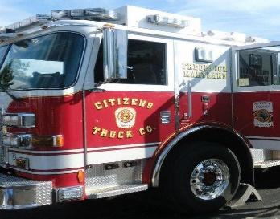
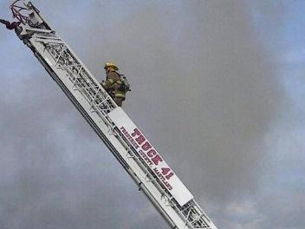
1st Prize ¼ Beef or $500
2nd Prize Country Ham and
$50 Hemp’s Gift Card or $100
3rd Prize 10lb Bacon or $50

Tickets $5.00 each – Drawling will be August 6, 2024
For Tickets email 2vicepresident.ctc4@gmail.com
Deputychief4.ctc@gmail.com
OR
Stop by Hemp’s Meat
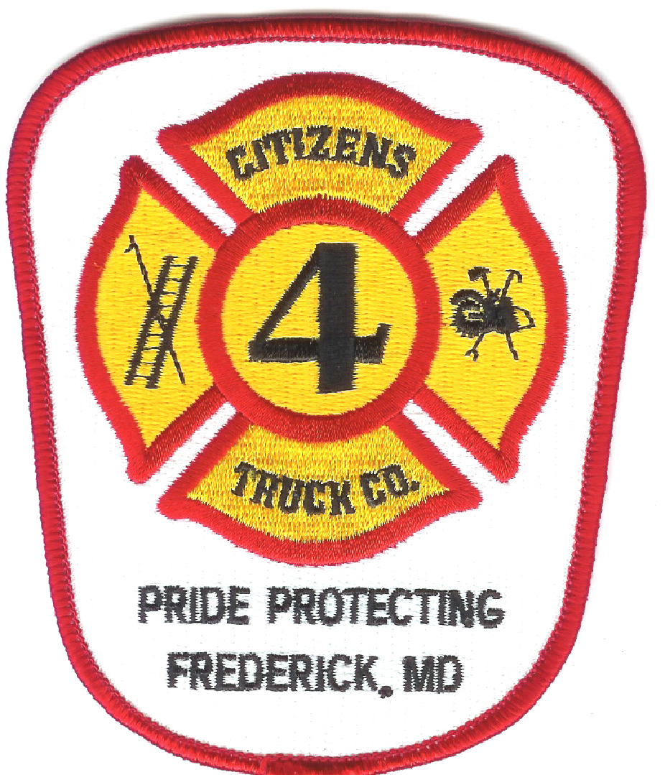
Meat provided by Hemp’s Meat Jefferson Maryland

